**DAILY ONLINE ACTIVITIES SUMMARY**

|  |  |  |  |  |  |
| --- | --- | --- | --- | --- | --- |
| **Date:** | **12-06-2020** | | **Name:** | **Shah Dhruvil Amit** | |
| **Sem & Sec** | **6th - B** | | **USN:** | **4AL17CS083** | |
| **Online Test Summary** | | | | | |
| **Subject** |  | | | | |
| **Max Score** |  | **Score** | |  | |
| **Certification Course Summary** | | | | | |
| **Course** | **Python programming** | | | | |
| **Certificate Provider** | **E-box** | **Duration** | | | **2 hours** |
| **Coding Challenges** | | | | | |
|  | | | | | |
| **Status: executed** | | | | | |
| **Uploaded the report in GitHub** | | **Yes** | | | |
| **If yes Repository name** | | <https://github.com/DhruvilShah99/Daily-Updates> | | | |
| **Uploaded the report in slack** | | **Yes** | | | |

Certification Course Details:

Report-

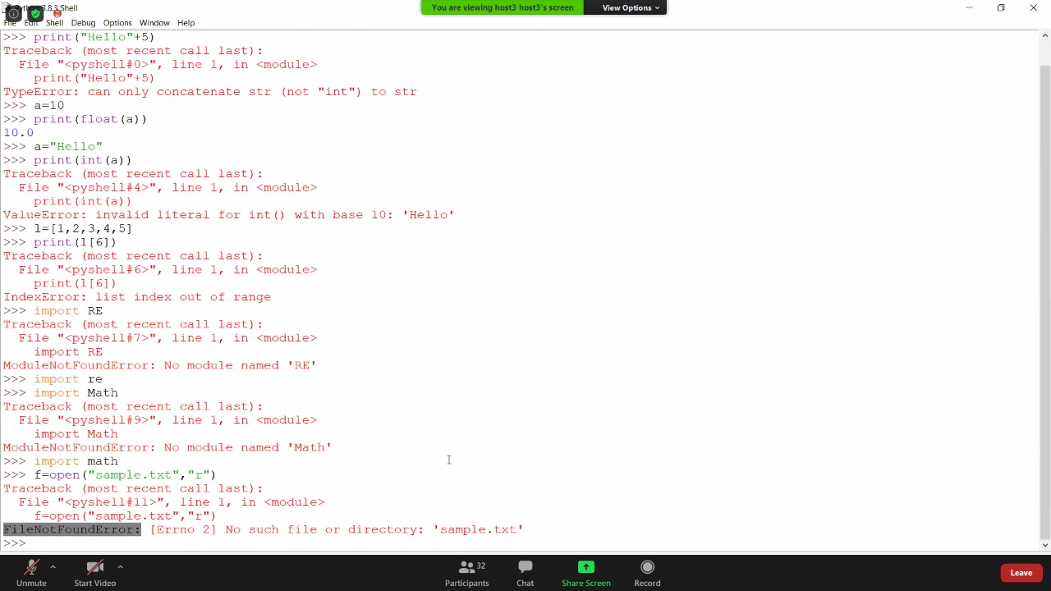

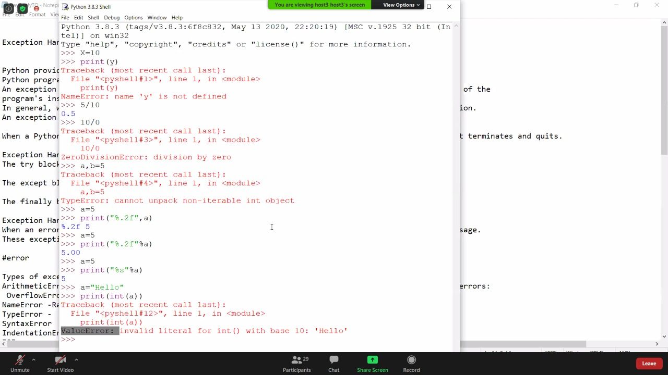

In todays session of online class, I have learnt about exception handling which handles the unexpected error such as divide by zero exception. And also learnt about different type of errors that occurs like syntax, indentation etc.

Coding Challenges Details:

The below GitHub link for details

<https://github.com/DhruvilShah99/Daily-Updates>

P-1

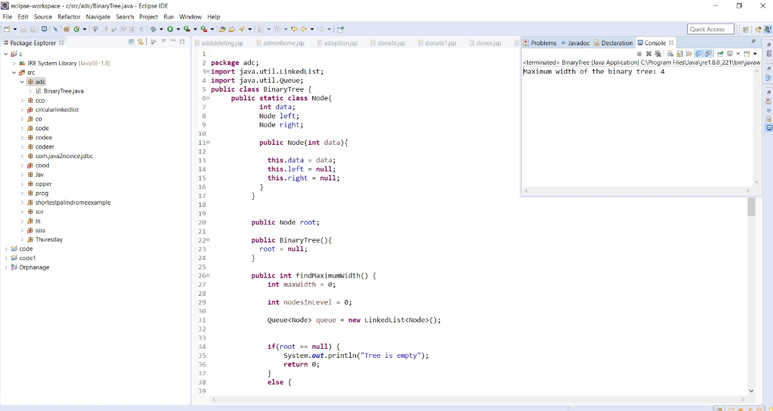

**P-2**

